*Client presentation for 12/01/22*

# Project Plan Client Presentation

**Project Plan Client Presentation** **1**

Project vision. 2

Main objectives: 2

Design 2

Administration 2

Side Objectives: 2

Security: 2

UML Diagrams 3

User Stories: 3

Class Diagrams: 5

Sprint plan 6

Risk management plan. 7

Legal Issues 7

Social Issues 7

Communication plan 8

Initial interface diagrams (sitemap, wireframes etc) 9

Sitemap 9

Initial Designs / Wireframes: 10

Home Page 10

About 11

Membership 12

Our Landscape 13

SHS Guide 14

Planning 14

Events 15

Contact Us 15

Admin Page 16

Initial prototype illustrating one key concept from the project. 18

## Project vision.

To create an informative and accessible website for the South Hams Society that will make a difference and inspire locals to save the environment around them and preserve it for the future generations.

List of project objectives.

### Main objectives:

#### **Design**

We are continuously enhancing our design based on the client's constructive feedback:

* improving the flow of the website so users have no problem with navigating
* testing that the design is accessible to all users is a big factor, such as:
  + ensuring text readability for users who are visually impaired
  + ensuring that the website has cross-device functionality, so it functions properly on phones as well as computers.

#### **Membership:**

Gaining membership is a crucial part of the South Hams Society website, so we have been working on developing a new membership form to replace the current pdf form.

This new membership form is aimed to be:

* Convenient - The user isn't required to scan or print the form, they only need to enter the details on the website.
* Easy to understand - Each input box will have a clear visual label indicating what the user needs to enter.
* Accessible - Clear and readable text, keyboard navigation, error messages.

#### **Administration**

Assuring that the website is manageable by you is a crucial objective.

* We have been working on the implementation of Drupal as requested by the client to allow the administrators of South Hams Society to manage content and maintain the website.
* We are aware that members of the South Hams Society will have different permissions, so we will be implementing permissions to:
  + prevent non-admin users from accessing/editing certain content on the website
  + add two different admin permissions, one admin role will have the ability to control the whole website, and the other will only be able to post.

### Side Objectives:

#### **Security:**

As today’s society moves more towards web technology and the internet, we are all for to make the website secure and safe for its user

* IP/Email Address Spam Proofing
* Secure Database for the logins
* DDoS Prevention

## UML Diagrams

set of requirements models. These should include the user stories, use case diagrams

and other appropriate UML diagrams that decompose the user stories.

### User Stories:

| User Type | Epic | Combined User Story |
| --- | --- | --- |
| Full Admin | Manage Social Media Posts | As a full website admin, I would like to able to manage the facebook posts that get shown on the website |
| Social Media Admin | As a social media admin, I would like to able to manage the facebook posts that get shown on the website |

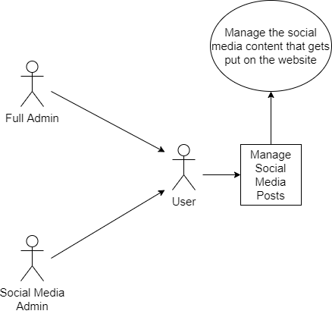

| User Type | Epic | User Story |
| --- | --- | --- |
| Full Admin | Manage content | As a full website admin, I would like to be able to manage the content and update it as regularly as needed to. |

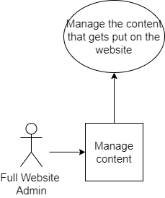

### 

| User Type | Epic | Combined User Story |
| --- | --- | --- |
| Full Admin | Browsing the website | As a full website admin, I would like to able to view the content on the website |
| Social Media Admin | As a social media admin, I would like to able to view the content on the website |
| Member | As a member, I would like to able to view the content on the website |

### 

### Class Diagrams:

Login Page for Users/Admins

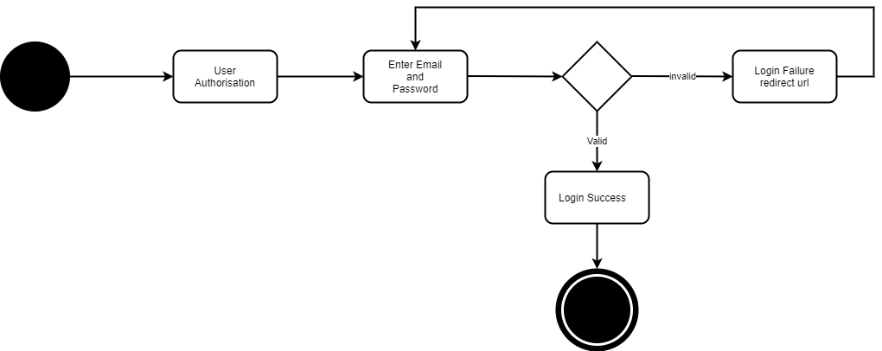

## Sprint plan

Showing when user stories will be developed by the team and an outline of what

will be released at the end of each sprint**.**

<https://tasks.office.com/live.plymouth.ac.uk/en-US/Home/Planner/#/plantaskboard?groupId=e87d7812-17f0-4095-8f99-16c2095a594a&planId=h5sVXiUYLUq-6ZmVql00uZYABS89>

## 

## Risk management plan.

#### 

Link: <https://docs.google.com/spreadsheets/d/1Lc6Kx1WnU_aczCIJ7aRQ3RLaPqAjvPXQF219p33J37c/edit?usp=sharing>

## 

## Communication plan

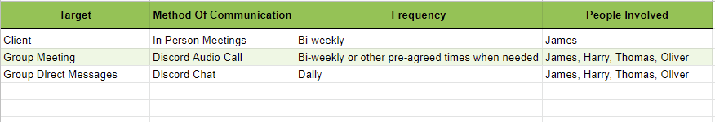

Communication is always vital when in a team so the ensures all team members can cooperate efficiently without losing time on overusing resources on a part where other part could benefit from it more

We have had weekly/bi-weekly meetings using Discord every Thursday or other pre-agreed times, this is to discuss and review the work that we had been performing and talk about forthcoming tasks and deadlines. We record the meeting events on a notepad then push it up to github. Also we use the chat feature to discuss our progress more regularly

Each team member has a responsibility to execute and complete their tasks properly on time. If for whatever reason one member is struggling and is seeking assistance then they should be given it to help push them forward in the right direction. It is acceptable if a team member is allocated more time to complete tasks that were in the backlog. The repository guidelines give instructions on the formatting of commits (establishing what content should be committed to an individual Git branch) for example.

.

## 

## Initial interface diagrams (sitemap, wireframes etc)

### Sitemap

Better View: Github Link to sitemap

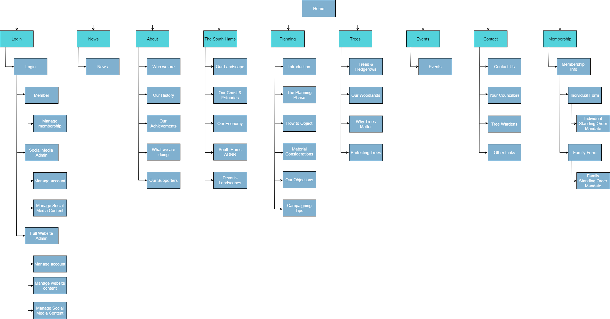

### 

### Initial Designs / Wireframes:

#### Home Page

### 

### 

### 

#### About

#### 

#### 

#### 

#### Membership

#### 

#### 

#### 

#### Our Landscape

#### 

#### 

#### SHS Guide

#### 

#### Planning

#### 

#### 

#### Events

#### 

#### Contact Us

#### 

#### Admin Page

#### 

#### 

#### 

## Initial prototype illustrating one key concept from the project.